Kubernetes Task-06
- Create a ConfigMap from a directory containing multiple files and inject the variables into a pod as environment variables.
  - Create directory and files
mkdir app-config
echo "dev" > app-config/APP_ENV
echo "8080" > app-config/APP_PORT
echo "mysql" > app-config/DB_TYPE
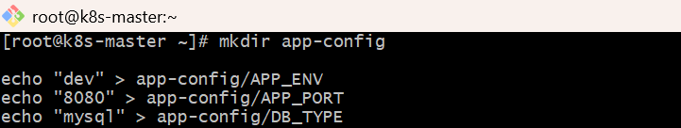
  - Create ConfigMap from directory
kubectl create configmap app-configmap --from-file=app-config
Check:
kubectl get configmap
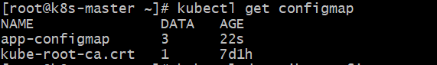
kubectl describe configmap app-configmap
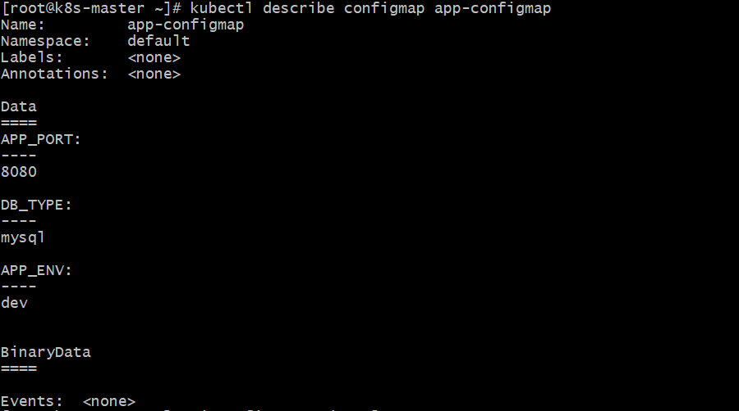
  - Create pod using ConfigMap as environment variables
Create file:
vi configmap-pod.yaml
Paste:
apiVersion: v1
kind: Pod
metadata:
name: configmap-env-pod
spec:
containers:
- name: nginx
image: nginx
envFrom:
- configMapRef:
name: app-configmap
Apply:
  - kubectl apply -f configmap-pod.yaml
  - Verify environment variables inside pod
kubectl get pods
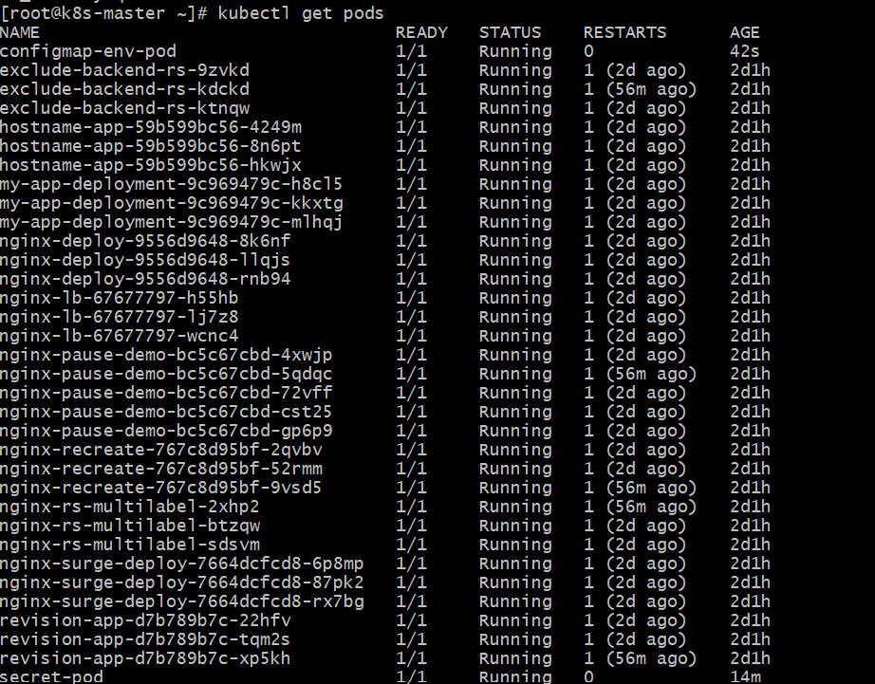
kubectl exec -it configmap-env-pod -- env | grep APP
kubectl exec -it configmap-env-pod -- env | grep DB

- Create a ConfigMap from a file and mount it as a volume inside a pod, ensuring the configuration data is available as files.
  - Create a file (config file)
Create a file on your system:
echo "Welcome to Kubernetes ConfigMap" > app.properties
  - Create ConfigMap from the file
kubectl create configmap my-config \
--from-file=app.properties
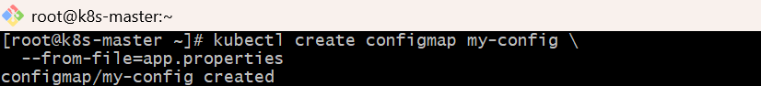
Verify:
  - kubectl get configmap
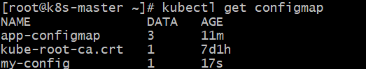
kubectl describe configmap my-config
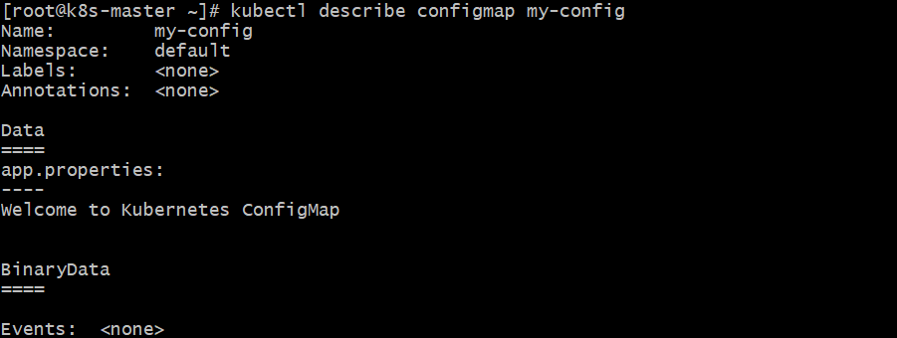
  - Create Pod YAML to mount ConfigMap as volume
Create a file:
vi configmap-pod.yaml
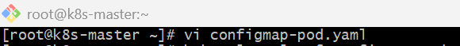
Paste this:
apiVersion: v1
kind: Pod
metadata:
name: configmap-pod
spec:
containers:
- name: nginx
image: nginx
volumeMounts:
- name: config-volume
mountPath: /etc/config # files will be available here
volumes:
- name: config-volume
configMap:
name: my-config
  - Apply the Pod
kubectl apply -f configmap-pod.yaml
Check pod:
  - kubectl get pods
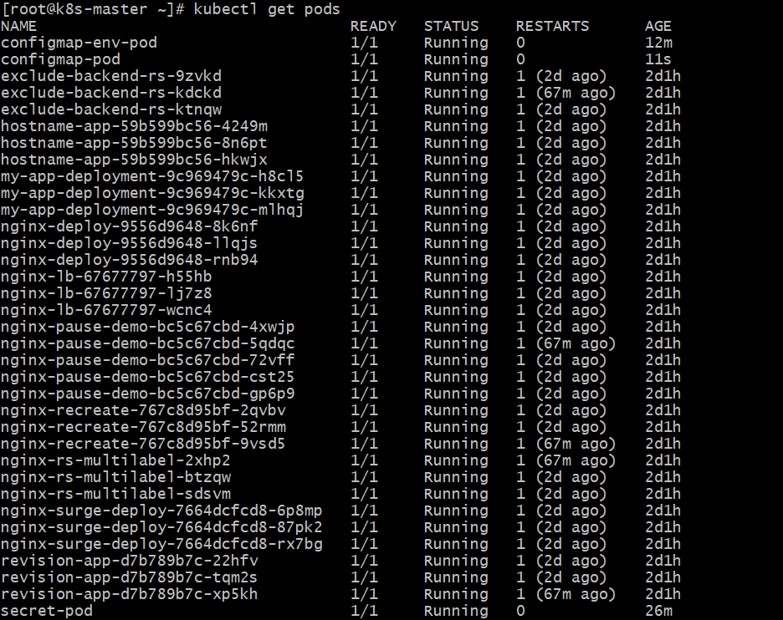
  - Verify inside the Pod
Login into pod:
kubectl exec -it configmap-pod -- /bin/bash
Check files:
cd /etc/config
ls
cat app.properties
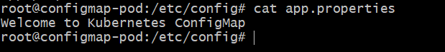

- Create a Secret with sensitive information (username and password) and inject it into a pod as environment variables.
  - Create a Secret
Using command (recommended)
kubectl create secret generic my-secret \
--from-literal=username=naseerbaba \
--from-literal=password=naseerbaba123
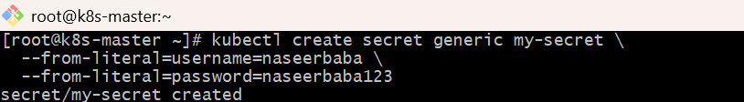
  - Verify Secret
kubectl get secrets
kubectl describe secret my-secret
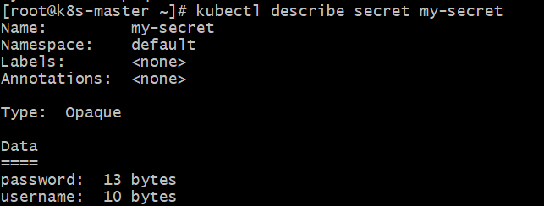
  - Create Pod and Inject Secret as ENV
Create file pod-secret.yaml
apiVersion: v1
kind: Pod
metadata:
name: secret-pod
spec:
containers:
- name: my-container
image: nginx
env:
- name: USERNAME
valueFrom:
secretKeyRef:
name: my-secret
key: username
- name: PASSWORD
valueFrom:
secretKeyRef:
name: my-secret
key: password
Apply it:
  - kubectl apply -f pod-secret.yaml
  - Verify inside Pod
kubectl exec -it secret-pod -- env | grep USERNAME
kubectl exec -it secret-pod -- env | grep PASSWORD
- Create a Secret using a YAML file, mount it as a volume in a pod, and verify the specific Secret values are available as files.
  - Create Secret YAML
Save as secret-volume.yaml
apiVersion: v1
kind: Secret
metadata:
name: app-secret
type: Opaque
stringData:
username: naseerbaba
password: Iqra@6293
---
apiVersion: v1
kind: Pod
metadata:
name: secret-volume-pod
spec:
containers:
- name: nginx
image: nginx
volumeMounts:
- name: secret-volume
mountPath: /etc/secret-data
readOnly: true
volumes:
- name: secret-volume
secret:
secretName: app-secret
  - Apply YAML
kubectl apply -f secret-volume.yaml
  - Verify Secret and Pod
kubectl get secret
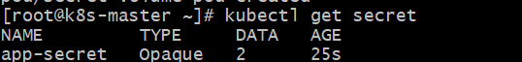
kubectl get pod secret-volume-pod
  - Check Secret files inside Pod
kubectl exec -it secret-volume-pod -- ls /etc/secret-data
You should see:
password username

  - Verify specific Secret values
kubectl exec -it secret-volume-pod -- cat /etc/secret-data/username
kubectl exec -it secret-volume-pod -- cat /etc/secret-data/password
Expected output:
naseerbaba
Iqra@6293
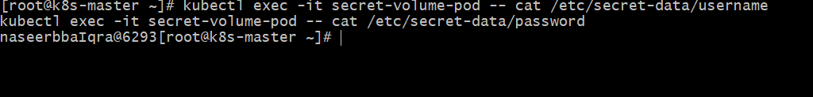
- Inject a ConfigMap as environment variables and a Secret as files into the same pod, ensuring both are accessible within the pod.
  - Create ConfigMap
kubectl create configmap app-config \
--from-literal=APP_NAME=myapp \
--from-literal=APP_ENV=dev
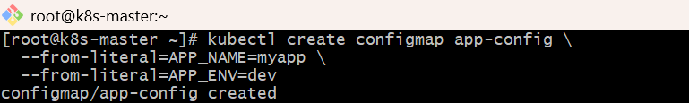
  - Create Secret
kubectl create secret generic app-secret \
--from-literal=username=naseerbaba \
--from-literal=password=naseerbaba123
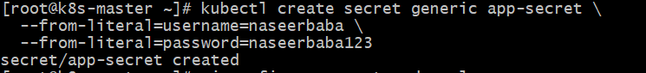
  - Create Pod YAML
vi configmap-secret-pod.yaml
Paste:
apiVersion: v1
kind: Pod
metadata:
name: configmap-secret-pod
spec:
containers:
- name: busybox
image: busybox
command: ["/bin/sh", "-c", "sleep 3600"]
envFrom:
- configMapRef:
name: app-config
volumeMounts:
- name: secret-volume
mountPath: /etc/secret
readOnly: true
volumes:
- name: secret-volume
secret:
secretName: app-secret
  - Apply Pod
kubectl apply -f configmap-secret-pod.yaml
  - Verify Pod
kubectl get pod configmap-secret-pod
  - Check ConfigMap environment variables
kubectl exec -it configmap-secret-pod -- sh
Inside pod:
echo $APP_NAME
echo $APP_ENV
Expected:
myapp
dev
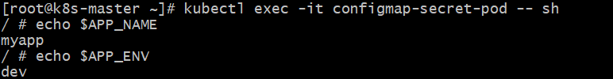
  - Check Secret files
Inside same pod:
ls /etc/secret
cat /etc/secret/username
cat /etc/secret/password
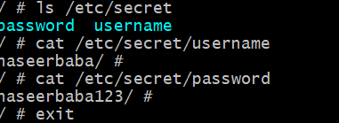
  - Clean up:
kubectl delete pod configmap-secret-pod
kubectl delete configmap app-config
kubectl delete secret app-secret
